**Weekly Report 10/21**

**MSiA-400 Group 1** : Ellen, Henry, Ishu, Enzo

Tasks Accomplished:

* (Tried to survive in the PA midterm)
* Loaded data sets into python for further analysis.
* Table descriptions and summary stats:

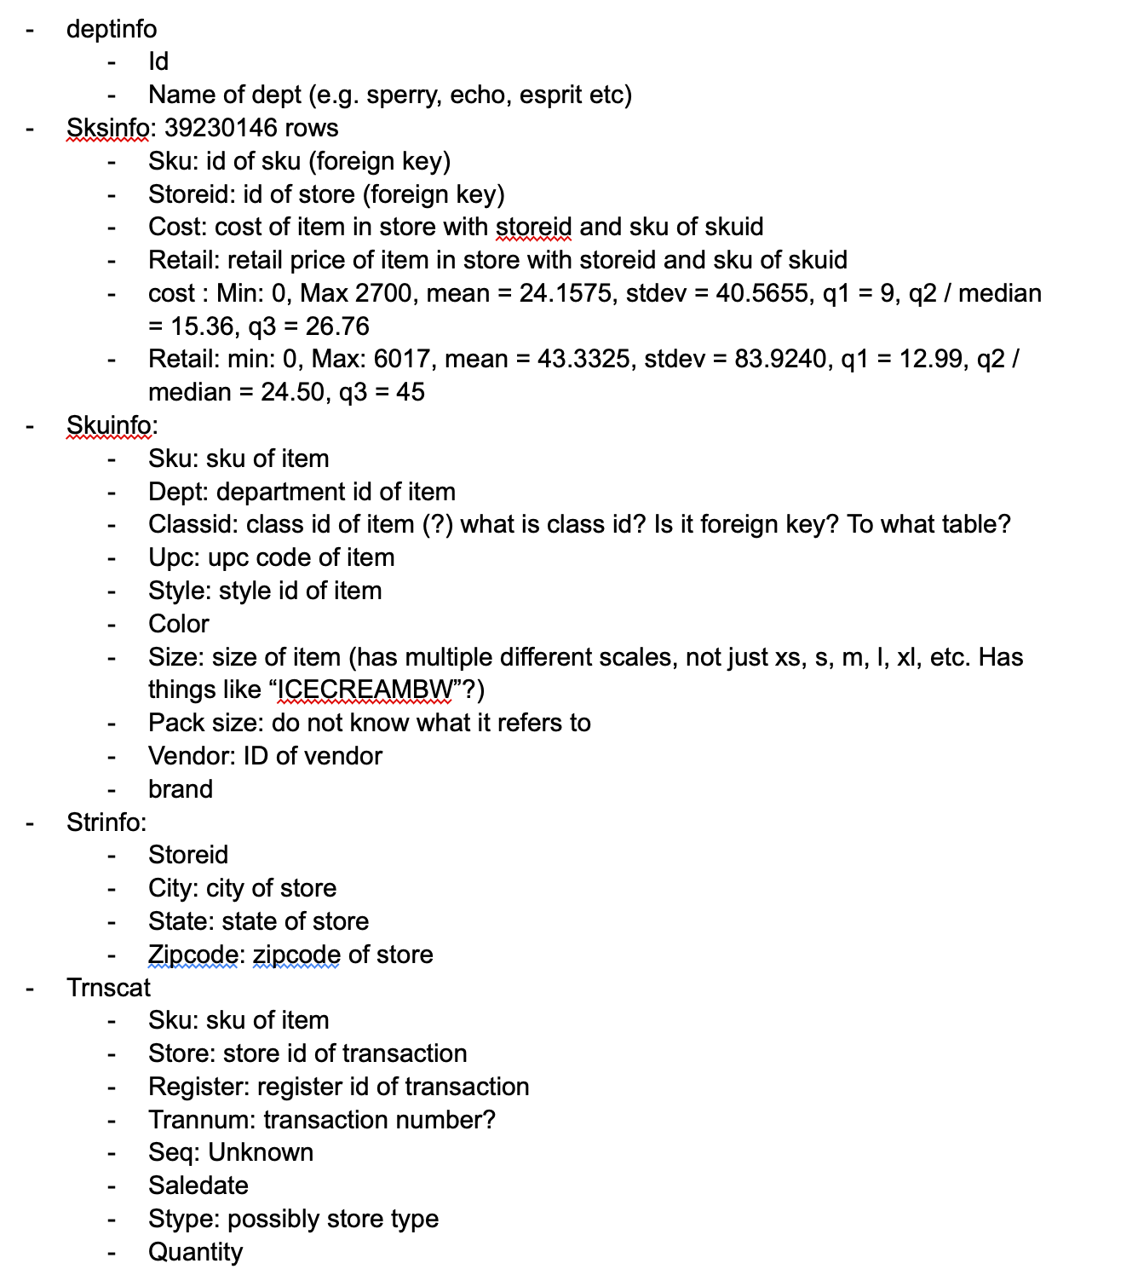

* Discussed the potential business questions for the project:

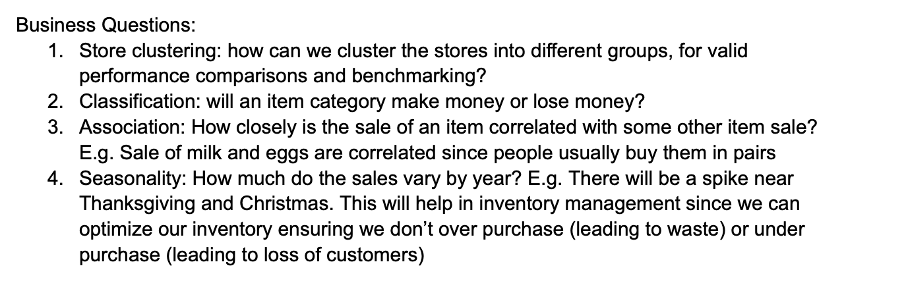

Plans for Next Week:

1. Complete table descriptions and summary statistics.
2. Continue data cleanning.
3. Try to finalize the business question for the project.